1.Draw a Use Case Diagram for an online Library Management System

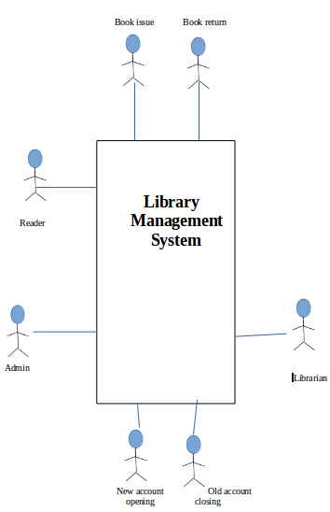

2)List down the best practices from Agile/Scrum methodology

More than a methodology, agile is a mindset. It is a way of thinking. The preferred practices in agile emphasise mainly on team work and collaboration. It is difficult to draw out a correct framework for scrum as it is always prone to change. A few advisable practices from scrum are discussed below.
- Customer Feedback
Customer feedback is a mandatory feature of scrum methodology. As customer satisfaction is given a high priority, a proper scrum system must ensure that customers always approach with feedback and suggestions. That said, care should be taken to ensure that the clients are not a part of the development team. If that occurs, cutomers can confuse the developers with suggestions that are unacceptable.
- Documentation Control
As a general practice, scrum prefers functional software over complex documentation. However, the complicated things in the design phase can be documented so as to ensure that confusions can be avoided at the later stages. The range of data to be documented should be precise. Documenting unnecessary or obvious data is an utter waste of time and energy.

- Co-location of team
Face to face conversation is extremely necessary in scrum. Inorder to ensure that, all the team members should be located close to one another. The orgasnisation should ensure that each scrum team should have all the members in close locations.
- Efficient retrospective meetings
Retrospective meetings are essential to ensure that the project is moving in the right direction. So steps should be taken to make sure that the retrospectives and reviews are all in place.
- Continuous integation
It is an obvious scrum practice. The softwares developed over sprints should be continuously fed to the clients and their feedback should be collected.
- Proper time planning
Sprint lengths should be ideally around 2-4 weeks. Sprint lengths are not supposed to be changed. However exceptions are allowed under extreme cases. 6 hours a day should be the realistic planning input.

3) Collaboration
a.How does collaboration help agile development?
b.What if the team is distributed and can you achieve the same productivity?
c.What would you do to achieve the productivity for a distributed team?

(a) In agile methodology, work is done in small groups. Unlike waterfall methodology in which individuals are given targets to achieve, here it is more about team work. Effective collaboration ofindividual efforts is necessary to carry out the works in an organised way. Even the slightest miscommunication among the members can cause serious troubles. Hence agile development needs collaboration. On the contrary, working in an agile may not make one a good team person. Its an adjustment in the mindset that every individual has to make. In agile, even if one of the team members falls short on certain aspects, his team can aid him and make up for him.

(b)If a team is distributed across different places, the productivity or quality of a team will not definitely reach the expectations. This effect is more enhanced in scrum as face to face conversations is a necessity there. A conversation over an email, a video conference or even a phone call may not be enough to cover for the lack of co-location. It can be safely assumed that for efficient collaboration, co-location is a must.

(c) If the team is distributed over a distance, working will get hard. Greater the distance, harder will be the work. So the best measure to do is ensure co-location. In case the distribution is unavoidable, the certain measures can be taken to atleast manage a reasonable productivity.
- Effective use of vcs, emails and calls.
- Ensure daily contact.
- If the distribution is over a same building, try to conduct at least the daily scrum meetings on time.
- Group chats through different media is necessary.
- All the team members should contact each other on a frequent basis.

4) What is Sprint Zero in Agile?Describe the activities that are done in Sprint Zero.
Sprint zero put simply is just making out the big picture. It isn’t a mandatory process or something that we should go by as enforced by a guideline.Still, teams prefer to do this to get a basic idea as to what they are getting into. Though planning is not an important activity in scrums, in sprint zero, we create the basic skeleton by use of minimal design. The activities done in sprint zero are as follows.
- Keeping track on product backlog
- Making a note on infrastructure availability
- Obtaining funding and support.
- Checking the team’s readiness etc

